HW 4 Lab Report

Jacob Alongi

Part 1:  **Global Thresholding**

* Load an image, call binaryThreshold
* Set initial Threshold (img.max()/2)
* Set the tolerance 10
  1. 
* Set pixel value to 0 or 255, if above threshold value -> 255
* Store in two separate arrays, low and high
* Calculate average pixel value for both
* If the difference of the two averages greater than tolerance, call recursive method binaryThreshRecursion until it is below
* Save results at each step, once done display them

Issues: none, this was pretty straight forward

Original | initial threshold | final threshold

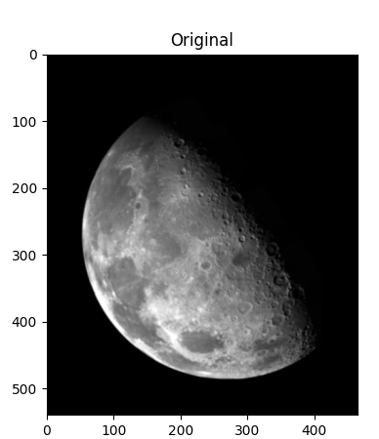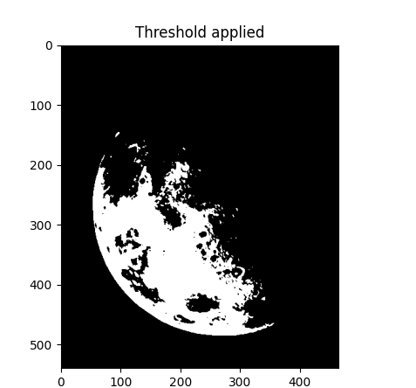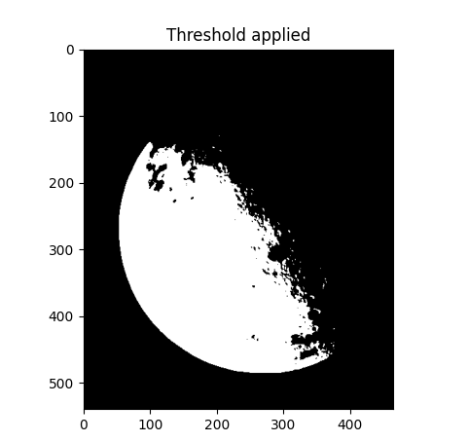

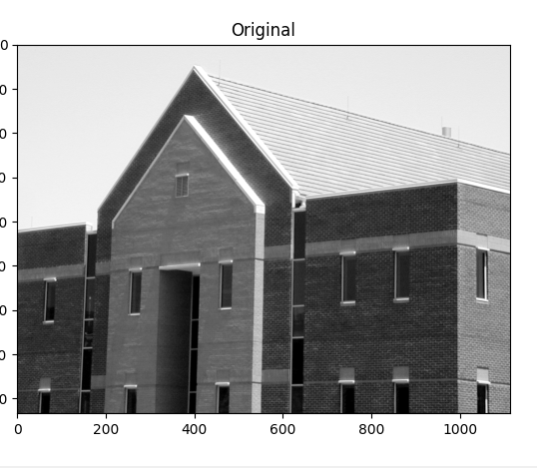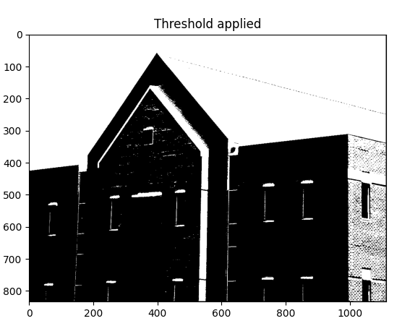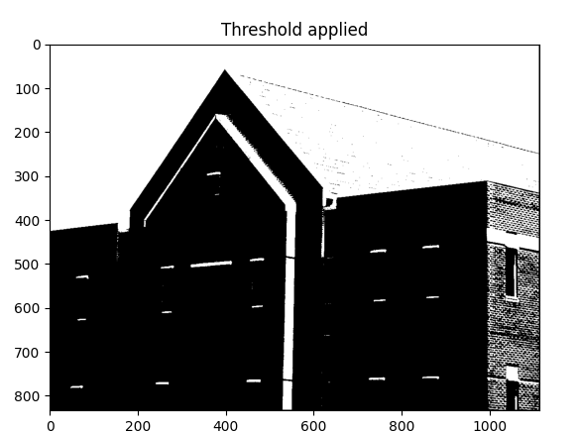

Part 2: **Image Segmentation using K-Means Clustering:**

Ran out of time its 10:47 -> results from code

Process:

Load image

Kmeans clustering -> cluster image

Cluster image -> split into 4 values,

Connected components set to 4 values for this example

Initial values are grabbed randomly and results can vary each time

